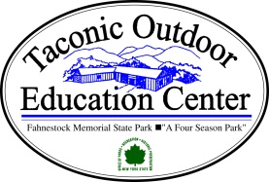

Join Pack 16 at our annual “Taconic Outdoor Adventure”
Saturday December 12 – Sunday December 13

Arrive: Promptly 9:00 AM Saturday Morning
Depart: After Closing Ceremonies Sunday Morning around 9:30 AM
Program: Advancement Requirements/ Games/ Campfire/ Hiking and Lots of Fun
Lodging: Heated main lodge with Fireplace
Comfortable heated cabins (Some with toilet facilities and showers others share common bath house)
Food: Saturday Lunch and Dinner, Sunday Breakfast Included
Snack assignments will be provided later.

Note that due to the popularity of this event and limited accomodations, 1 parent to one scout will be permitted.
A second parent or sibling(s) will be permitted on a first come first serve basis only after Scouts are served first.

Scouts Name: ________________________________________________

Rank and Den Number: ________________________________________________

Parent Attending: ________________________________________________

Others Requested Space Permitting ________________________________________

Home Phone: ___________________ Cell Phone:__________________

Total Non- Scouts Attending: ___________ X $75.00 each = ______________

Scouts Attending (thx Popcorn): ___________ X $65.00 each = ______________

Leaders Attending: ___________ X $65.00 each= ______________

Total ______________

Please return your forms and checks made payable to Pack 16 to your Den Leader no later than Friday November 20. If additional space is available you will be notified at that time.

