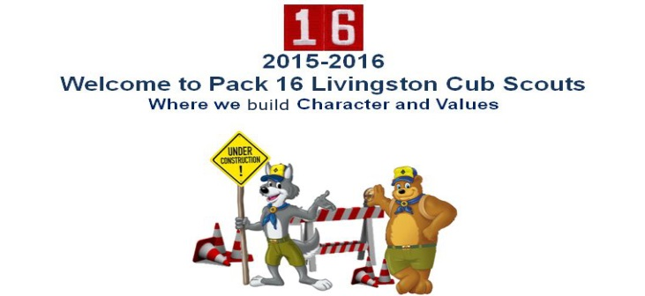
Pack 16 Cubmaster
Larry Levine
(917) 549 – 0346
llevine@inwk.com
Pack 16 Popcorn Kernel
Scott Kuperman
(973) 336 – 4911
sckuperman@yahoo.com

Thursday, September 17, 2015
Dear Parents,
Another year of fundraising through Popcorn has begun. You experienced our Popcorn Kick Off at our first 2015 annual Pack meeting and should be roughly aware of our fund raising program and what makes it so important. Here are the plain facts and documents to help you through our program and make it easy to sell popcorn:
- Please download our Excel spreadsheet template and print your “Take Order” forms as needed. You only need to print the first page (on legal paper or larger) to be filled out by hand. Keep them neat and legible! When you have completed one full page of 30 individual orders, please enter the data into the spreadsheet on your computer and edit your name, den, etc on the left. Generate a custom barcode by enabling macros in your program and clicking on the barcode button. Save the file and submit to your Den leader as soon as possible for an entry into the weekly prize drawing from Council. Continue taking orders on a new printed sheet and repeat the process until 10/31/2015. At that time, ALL electronic spreadsheets must be submitted to your Den leaders for the orders to be placed!
When it comes time to deliver your popcorn by hand, print your spreadsheets and you will see an easy to follow form autopopulated by information from your entries. Print double sided for easiest reading.

- Please download and print our Popcorn Products flyer. This too can be printed on legal sized paper. Make sure to keep this with your order form and show it to everyone to whom you are selling! Make sure you and your Scout know our product and what they cost!

- Go online to http://sell.trails-end.com in order to create an account to sell online. You’ll also be able to download a toolkit, reference material, door hanger templates for leave behinds when selling door to door, “Thank You” card templates, banners, and more.

- Open a Square account to accept credit cards for your orders. The process is simple and is outlined in our separate document for Square Credit Card processing.
Please remember that 10/3 and 10/4 are VERY important dates for our BLITZ and SHOW n’ SELL activities! Keep these dates open and attend for fun and popcorn!
Yours In The Fellowship Of Scouting,
Scott Kuperman
Pack 16 Livingston Cub Scouts

