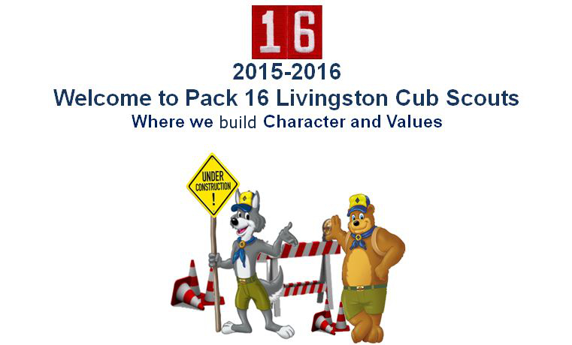

Pack 16 Cubmaster
Larry Levine
(917) 549 – 0346
llevine@inwk.com
Pack 16 Popcorn Kernel
Scott Kuperman
(973) 336 – 4911
sckuperman@yahoo.com

DATE
Dear Mr. Executive,
Cub Scout Pack 16 has been building Character and Values with our youth in Livingston for over 65 years. We are a completely non-profit, unpaid volunteer driven organization that serves our community and supports our local businesses by making our towns safer and a richer place to live and work.
We would like the opportunity to work with you while we mutually benefit from your generous, tax-deductible purchase of our popcorn products during our 2015 annual fund raiser! Every year we sell delicious, custom-branded Trails End© popcorn products that everyone loves to eat. Over 73% of each dollar invested in our popcorn products goes directly to Scouting and helps us to run our program that includes science, technology, engineering, and mathematics learning programs, as well as camping, and real world experiences that build self-reliance and life skills for our youth.
Please think of gifting our popcorn products to your clients to build your customer relationships and honor their patronage. Perhaps your employees deserve exceptional praise for jobs well done this year. Consider donating our popcorn to our active United States military personnel in your clients’ names! In return, our Scouts will hand deliver your popcorn to your business. At that time we will pose in uniform, with our flags and banner, along with your staff in front of your business for a photo session. Frame and hang this photo on your wall with pride as a reminder of your service to our community in support of Scouting. Release a press memo to bring additional publicity for your business.
Attached is our brochure describing the high quality products and military donation services we offer. As an added incentive, if your total business order exceeds $500 by October 20, 2015 we will include a free bag of our Classic Caramel Popcorn just for you! You can pay by company check, or pay by credit card and earn points or miles with your order. We hope you can contribute to our efforts to improve our youth program this year and look forward to working with you. Thank you very much for your consideration!
Yours In The Fellowship Of Scouting,
Scott Kuperman
Pack 16 Livingston Cub Scouts

