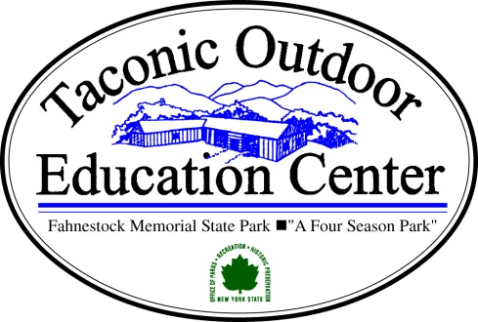
Directions

Route 280 East to
Garden State Parkway North for +/- 25 miles
Merge onto Gov. Thomas E Dewey Thruway North / East
Exit 14-1 stay right follow signs to I-87, I-287 New York City
Take Ramp Left towards I-287 Tappan Zee Bridge
Exit at 13N onto Palisades Interstate Parkway North
Proceed +/- 19 miles (road changes to US-6)
At circle follow signs towards RT-202, US-6, Bear Mountain Bridge
Proceed +/- 4.2 miles and over Bear Mountain Bridge
At circle follow signs to RT-9D North (Albany Post Road)
Proceed +/- 10 miles
Turn Right (east) onto SR-301
Proceed +/- 2.5 Miles
Turn Right onto Dennytown Rd.
Proceed ¼ mile turn Right onto Indian Brook Road
Proceed ¼ mile turn Left onto Mountain Laurel Lane.
Follow Signs to Highland Lodge.
On Expedia.com Enter Dennytown Rd, Cold Spring, NY 10516

